# Study Material

**Unit 05: Transport Layer Class: SY IT**

**Unit V: Transport Layer**

Services, Berkley Sockets, Addressing, Connection establishment, Connection release, Flow control and buffering, Multiplexing, TCP, TCP Timer management, TCP Congestion Control, Real Time Transport protocol(RTP), Stream Control Transmission Protocol (SCTP), Quality of Service (QoS), Differentiated services, TCP and UDP for Wireless..

# Need of Transport Layer: Because Network Layer

Is the part of communication subnet and run by WAN carrier? Unreliable

Connectionless

Packet loss may happen Data mangling may happen Router may crash

# Transport Layer:

Ultimate goal is to provide efficient reliable and cost effective service. To enhance the QoS provided by network layer.

# The Transport Layer Provides:

Both connection-oriented and connection less services Addressing

Flow control Congestion control

As well as QoS using various timers

# Services provided to Upper Layer and lower layer

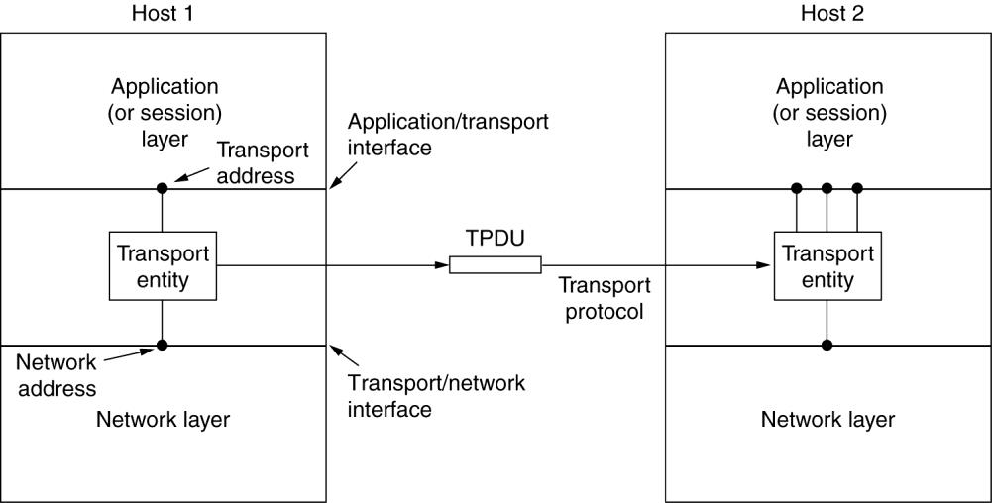

**Transport Service primitives:** To allow user to access the transport services.

Transport layer service provides some operations to application program, it is called transport service interface

# Basic Primitives:

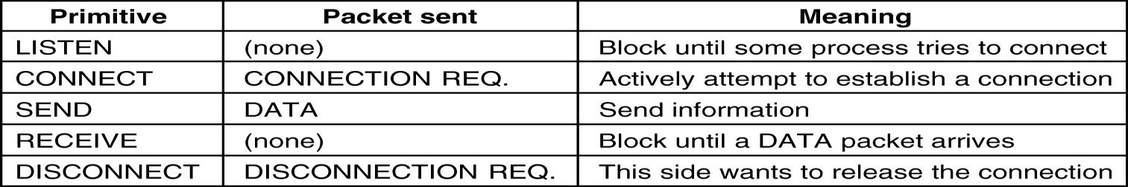

**Berkeley Sockets**

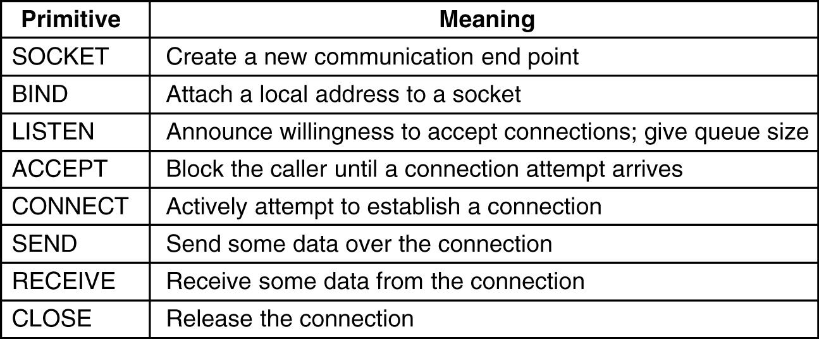

# Programming Steps (General)

**Step I:** Create/Open a socket. Use socket() command Syntax : socket(int af, int type, int protocol)

where af is address family for TCP/IP af =PF_INET and others af = AF_INET type = SOCK_STREAM or SOCK_DGRAM or SOCK_RAW

protocol = 0 for TCP/IP

**Step II:** Name the socket: Attach attribute to the socket like protocol, port, address Use struct sockaddr_in

Struct sockaddr_in serv

serv.sin_family=AF_INET; serv.sin_addr.s_addr=inet_addr("10.0.0.111"); serv.sin_port=htons(13);

**Step-III:** Associate with another socket

bind(int socket, struct sockaddr, int namelen));

# Client Side :

Use connect() command to establish connection with remote machine

Connect(int server_socket,(struct sockaddr *)&serversocket, int len(serversocket))

# Server :

Use listen() command to check for incoming connection from remote machine And then use accept() commands for accepting connection

listen(int Server_Socket,int backlogConn);

ServerSocket = accept(int Server_Socket, int Remote_Socket, int *addresslen);

**Step IV:** Use send() or sendto() commands for sending data.

send(server_socket,sendbuff,strlen(sendbuff),0);

int sendto(sockfd,buff,buffsize,0,(struct sockaddr *) &clientaddr, int clientaddr_len)

Use receive() or receiveto() for receiving data

int recv(server_socket,recv_buff,strlen(recv_buff),0);

int recvfrom(listenfd,buff,buffsize,0,(struct sockaddr *) &clientaddr, int *sockaddress_len)

**Step V** : use close() command to disconnect the connection Close(socket)

**Bare-bones Superstructure for TCP Client Server Socket Programming**

|  |  |
| --- | --- |
| **Client** | **Server** |
| Socket Creation: socket() | Socket Creation: socket() |
| Initialize sockaddr_in structure with  **remote** socket name | Initialize sockaddr_in structure with  **local** socket name |
| bind() | bind() |
|  | Listen() |
| connect() → |  |
|  | accept() |
| send() → | recv() |
| <Association created, either side can send or receive> | |
| recv() ←----------------------- | send() |
| closesocket() | closesocket() (Connected Socket) |
|  | closesocket() (Listening socket) |

**Bare-bones Superstructure for UCP Client Server Socket Programming Set The Remote Socket Name Once**

|  |  |
| --- | --- |
| **Client** | **Server** |
| Socket Creation: socket() | Socket Creation: socket() |
| Initialize sockaddr_in structure with  **remote** socket name | Initialize sockaddr_in structure with  **local** socket name |
| bind() | bind() |
| connect() → | Listen() |
| sendto() → | recvfrom() |
| <Association created, either side can send or receive> | |
| recvfrom() ←----------------------- | sendto() |
| closesocket() | closesocket() (Connected Socket) |

**Bare-bones Superstructure for UCP Client Server Socket Programming Set The Remote Socket Name For Each Datagram**

|  |  |
| --- | --- |
| **Client** | **Server** |
| Socket Creation: socket() | Socket Creation: socket() |
| Initialize sockaddr_in structure with  **remote** socket name | Initialize sockaddr_in structure with  **local** socket name |
|  | bind() |
| sendto() → | recvfrom() |
| recvfrom() ←----------------------- | sendto() |
| closesocket() | closesocket() |

# Byte Ordering

**Host Byte Order** :Little Endian ( Intel) 0007 MSB to LSB **Network Byte Order** : Big Endian (Motorola) 7000 MSB to LSB

inet_addr("10.0.1.111")- converts IP into 32 bit address

inet_ntoa(32-bit IP address) – convert IP address into std dotted notation

hton**s**(10001): convert host byte order to network byte order

hton(**s**) – s is unsigned short integer

htonl(**l**) – l stands for unsigned long integer

Htonl and ntohl and inet_addr(IP address)

# TCP/IP Network Components

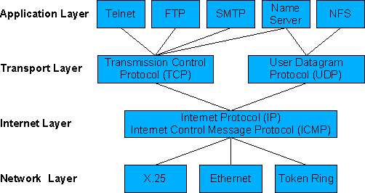

**TCP**

* Port Numbers
* 32-bit Sequence Number
* 32-bit Ack Number
* Flags : URG, ACK, PSH, RST, SYN, FIN
* Urgent Pointers
* Connection Oriented
* Reliable
* Full Duplex
* ID Assignment to multiple virtual circuits
* Works with IP
* Maintain the sessions

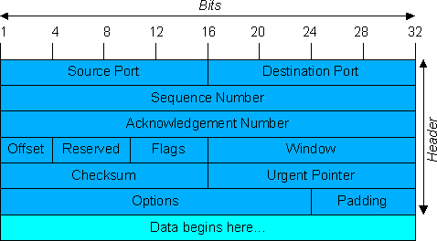

# TCP Frame Format

|  |  |  |  |
| --- | --- | --- | --- |
| Source Port | | | Destination Port |
| Sequence Number | | | |
| Ack | | | |
| Header  Length | Reserved | Flags | Window Size |
| TCP checksum | | | Urgent Ponter |
| Data | | | |

Flags : UGR, ACK,PSH, RST, SYN, FIN

# Functions of TCP

* 1. Reliable, Full Duplex and connection oriented
  2. Works with IP to move the packets
  3. Assign connection id to each virtual circuit
  4. Provides message fragmentation and reassembly using sequence number
  5. Error checking is enhanced through the use of TCP acks
  6. Error detection and correction
  7. Does not support broadcasting and multicasting
  8. Byte stream boundaries are not preserved end to end
  9. Min segment size is 556 bytes
  10. Provides flow control using sliding windows protocol

# Functions of DLL and TL?

Sequencing, Flow Control and Error Control.

# Why DLL and TL has the same functions?

|  |  |  |
| --- | --- | --- |
| Parameter | DLL | TL |
| Routing | Communicate directly through physical channel  Uniquely identifies next router.  Explicit addressing is not required | Communicate through subnet  Explicit addressing of destination router is required.  Connection establishment is required |
|  | Less storage capacity is required | Potential capacity is required |
|  | Can handle less connection | Handle large number of connections  with dynamic buffer mgt. |

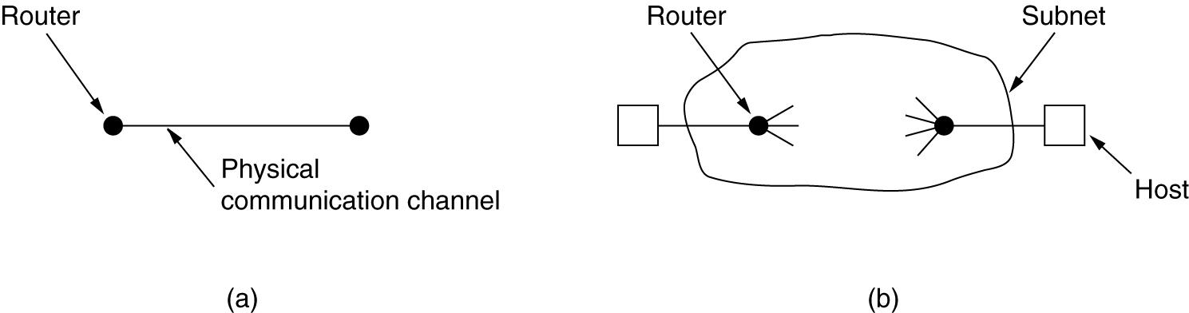

**Elements of Transport Protocols**

* Addressing
* Connection Establishment
* Connection Release
* Flow Control and Buffering
* Multiplexing
* Crash Recovery

# Addressing : How client application knows on which port service is running on the server?

Standard ports : /etc/services

Inetd/process server/name server/directory services

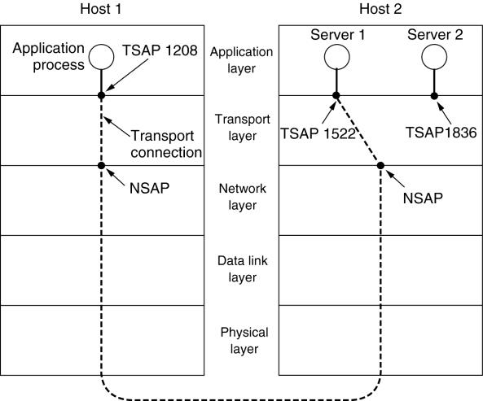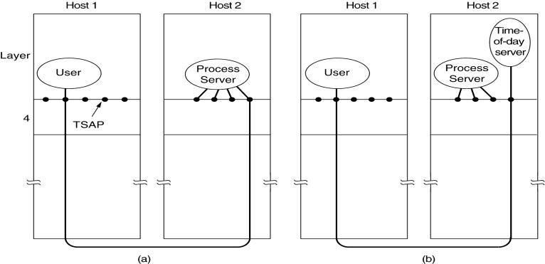

# Connection Establishment

Sounds easy but surprisingly tricky

**Bank money transfer**: delayed packet issue, time out problem (Problem is solved in Sliding window problem)

Kill off the aged packets that are hobbling around **Sol:**

**Restricted subnet design**: prevent packet from looping by putting boundary delay **Hop counter:** hop count will be decremented and reaches to zero

**Time stamping:** Requires time synchronization

|  |  |
| --- | --- |
| 6-11 | 6-11 |

Three protocol scenarios for establishing a connection using a three-way handshake. CR denotes CONNECTION REQUEST.

1. Normal operation,
2. Old CONNECTION REQUEST appearing out of nowhere.
3. Duplicate CONNECTION REQUEST and duplicate ACK.

# Three way handshake by Tomlinson-1975

SYN(seq=x)

SYN(seq=y,ack=x+1)

(seq=x+1,ack=y+1)

**Connection Release** Asymmetric release - telephone

Symmetric release – tcp, pair of two simplex connection FIN

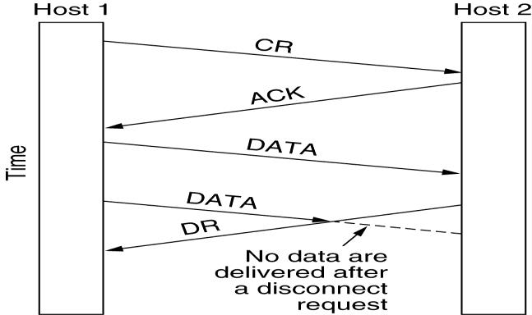

**Two army problem** : Blue Army on hillside and white army in valley

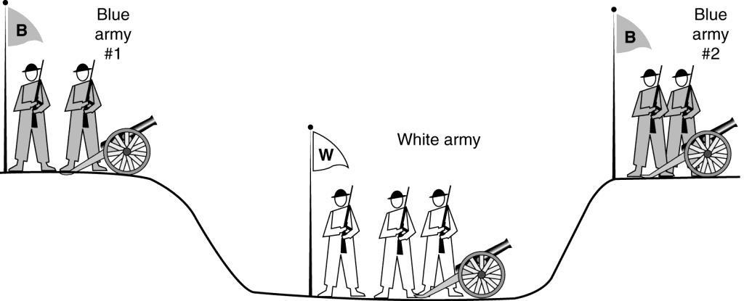

# Three Way connection release

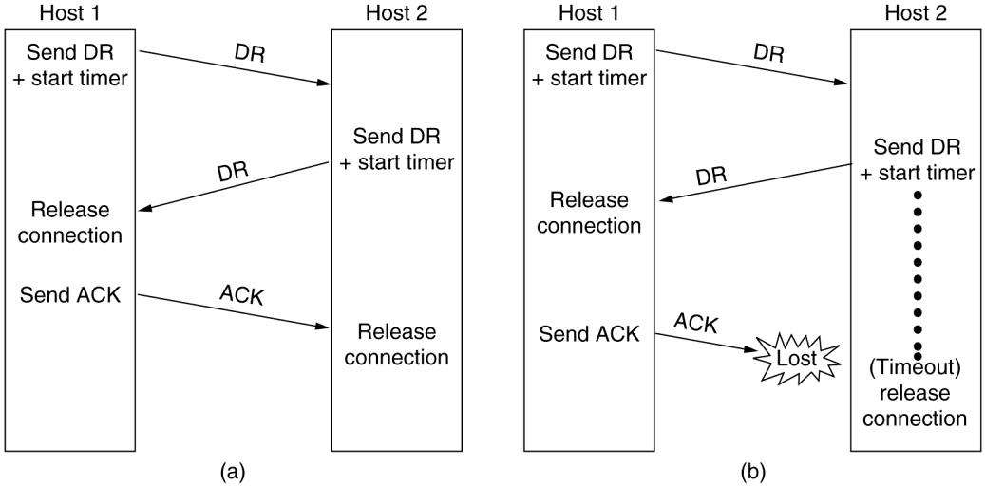

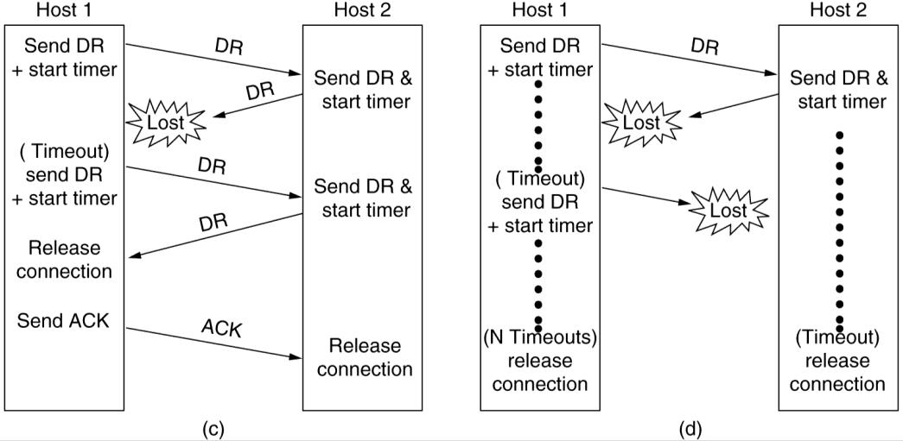

***Fig. Four protocol scenarios for releasing a connection. (a) Normal case of a three-way handshake. (b) final ACK lost. (c) Response lost. (d) Response lost and subsequent DRs lost.***

**Multiplexing**

Upward multiplexing and downward multiplexing

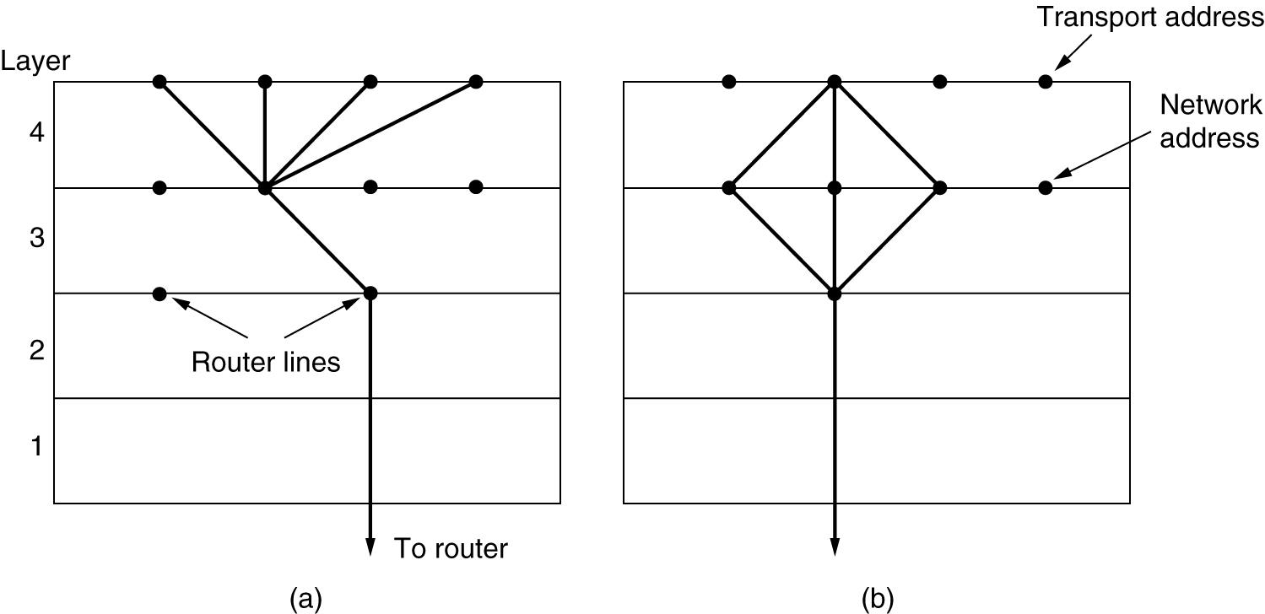

***Fig (a) Upward multiplexing. (b) Downward multiplexing.***

Crash Recovery

Loss of VC is handed by handling new connection

If server is crashed announce by broadcast and ask client to tell the status. Or Server must have logger

**Flow control and Buffering**

Use a sliding window protocol to have a fast transmitter to accommodate overrunning a slow receiver

Host server may have multiple connections available but what about the number of lines available with a router?

**Buffering**

In DLL sender and receiver knows the buffer available and accordingly buffers the packets at both the side

**Static/Fixed buffer size**: But frame may have variable size **Maximum TPDU Size:** Wastage of memory

**Variable size TPDU:** better utilization but complicated buffer mgt required

# Application Oriented Buffering

For interactive application : Low b/w : sender can buffer

High b/w : receiver can buffer

Buffer space must be related with the carrying capacity of the subnet. Sender must dynamically adjusts the window size to match the n/w carrying capacity

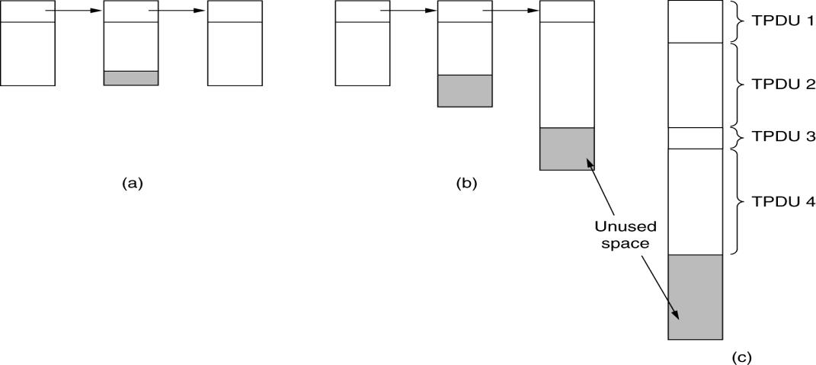

Fig (a) Chained fixed-size buffers. (b) Chained variable-sized buffers.

(c) One large circular buffer per connection.

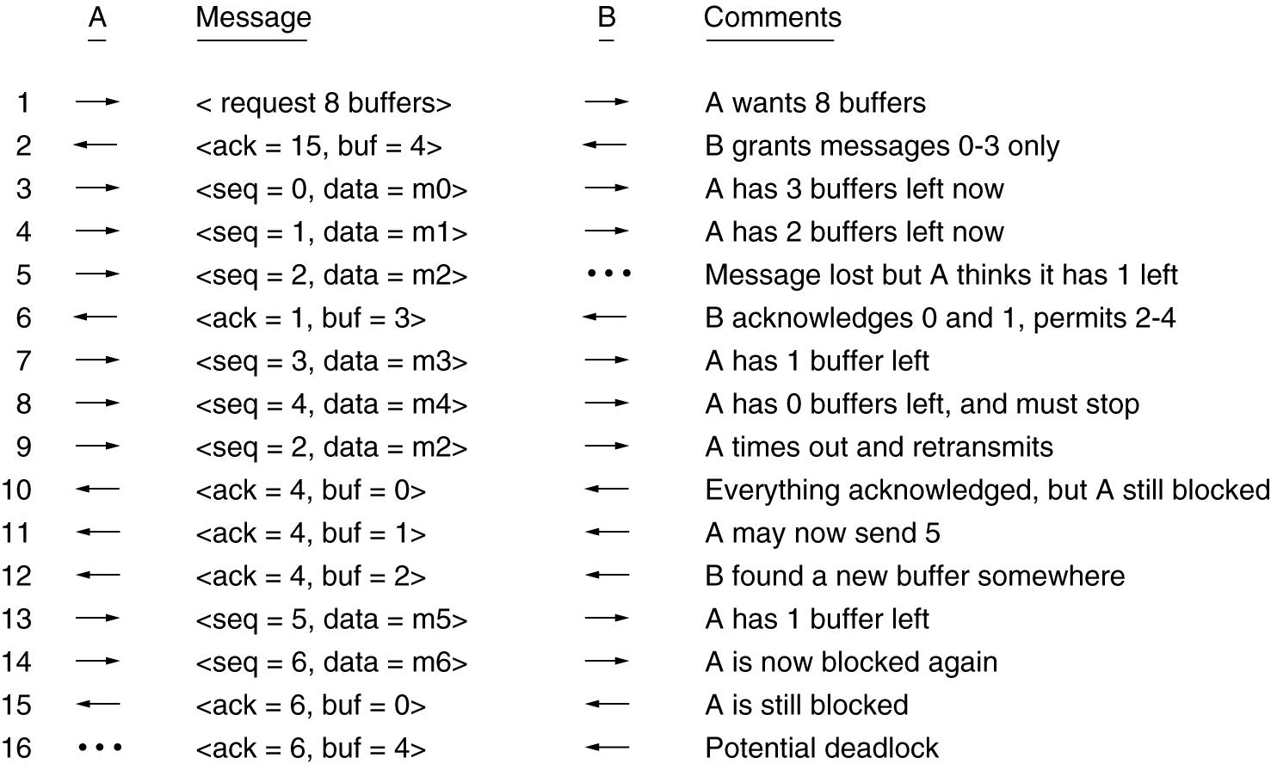

*Dynamic buffer allocation. The arrows show the direction of transmission. An ellipsis (…) indicates a lost TPDU.*

**TCP Transmission Policy**

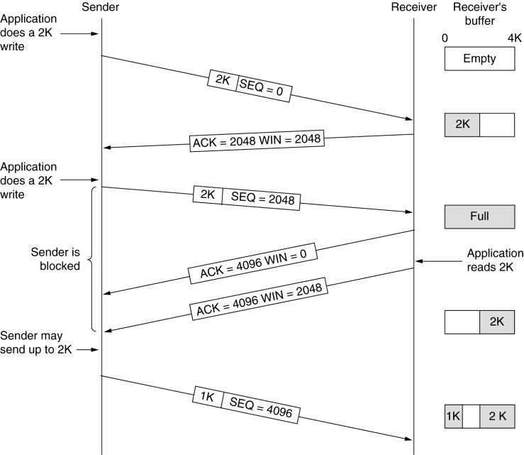

**Silly Window Syndrome :** Whenever one of the application program creates data very slowly then it reduces the efficiency of data transfer operation. Sometimes TCP sends only 1 byte of data, this problem is called Silly Window Syndrome.

**Nagle’s Theorem** : Never send a data without ACK is received. Buffer the data and when ACK is received then only send the data.

**Clarks Solution for fast sender**: Sending zero window size till buffer becomes available (either half or full)

**Delayed Ack problem** : Never send ACK to sender till enough buffer is available

**Karn Algorithm** : Double the time is ack is not received

**TCP Timer Mgt**

***Retransmission Timer:*** For the lost or discarded segment this timer handles the retransmission time, the waiting time for ACK.

Normally it is 2 x RTT

***Persistence Timer****:* Zero Window Mgt

***Keep alive Timer:*** Used to prevent long idle /silent connection. Send the probe packet after 2 hours and terminates the connection.

***Time Waited Timer:*** It is normal TCP connection termination after FIN is received. After the ACK sent for ACK , connection is closed after 2 packet lifetime

**TCP Congestion Control**

Retransmission is not the solution

Actual Window Size = min( receiver WS , congestion WS)

**Congestion Avoidance :**

*Slow Start:* Start with 1 segment, get ack for first segment then send 2 segment, get ack, send 3 seg etc

*Additive Increase : Increase exponentially upto some threshold and then increase by one*

*Multiplicative Decrease*: If congestion occurs reduce the flow exponentially.

# UDP

* Provides a *lossy* connection (data may vanish).
* Does not guarantee packets are delivered in order.
* Useful for real time applications.
* 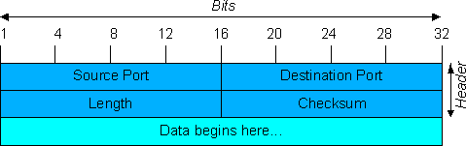UDP applications can implement their own packet loss checking but it is best to use TCP for this.

Connectionless , unreliable

No ack, No flow control , no error control Less overhead hence more efficient

Used for simple request reply applications

Echo, daytime, quote of the day, dns, bootp, tftp, rpc, NTP, snmp, audio and video conferencing

Supports multicasting and broadcasting Only 8 byte header

# Remote Procedure Call

